1. Import the rar file in your PyCharm Projects.
2. Install all the libraries required for the project either by PyCharm terminal or the error symbol showing adjacent to code line that shows missing library.
3. Start XAMPP server(Install it from <https://www.apachefriends.org/download.html> if you don’t have it)OR You can also use MySQL command line, but using XAMPP server is comparatively easier. (SQL is for storing results of analysis, login database, etc, so either XAMPP server of MySQL has to be running to run the code.)
4. Start Apache and MySQL service in XAMPP.

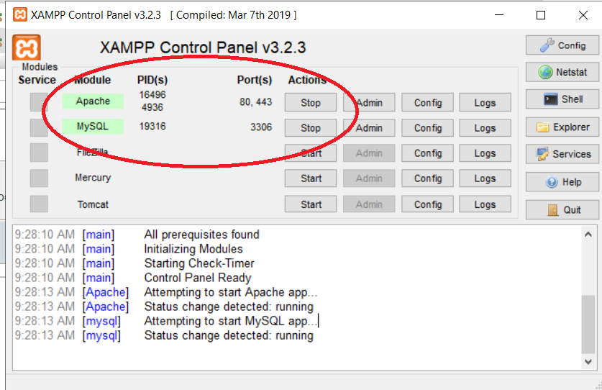

1. Create a database named twitteranalysis that include tables: login_table, olddata, twitterdata, twittertrends.

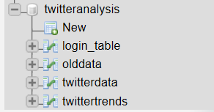

1. login_table schema should be:

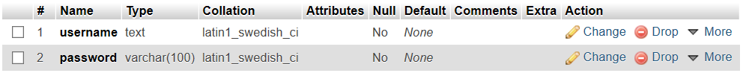

1. You can have one record in the login_table to access the service, or you can register through the interface later on.

Screenshot (424)

1. olddata table schema should be:

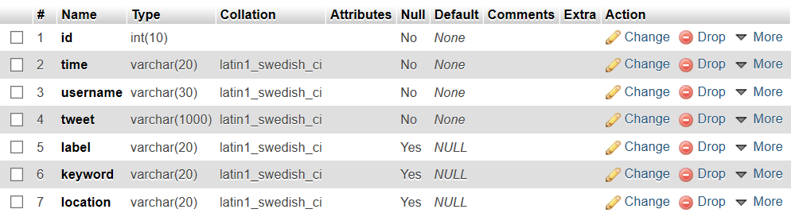

1. twitterdata table schema should be:

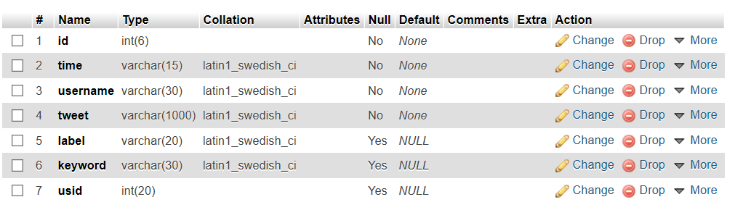

1. twittertrends table schema should be:

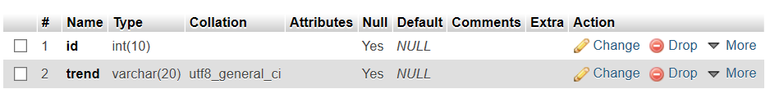

1. In the code, edit lines ‘59’, ‘344-347’, according to your MySQL server information i.e. user, password, database and host.
2. Now run the code.
3. Click on the hosted link to access the service (for eg: http://127.0.0.1:5000/ )
4. You can access the service now through login or registration. You can choose to find trolls based either on Generic search (Globally searches all tweets) or Individual keyword seach. Searching tweets and analysis tweets would take some time. Once it is done, data is stored in database, and the analysis is shown on the next web page. The result page shows graphical analysis as well as tweets labeled into trolls tweet and not a troll tweet. There is a download report button below the reports, so you can download .pdf files of analysis. There is also a report button adjacent to each tweet so that user can report any tweets he finds offensive (reported tweet is redirected to twitter).